    - Graph Theory for Cybersecurity Risk Management in PLC Security
Graph-based models allow for dynamic and scalable risk assessment in complex environments like ICS (Chen & Lu, 2023). Its benefits include:
  - Attack Path Analysis: it identifies possible attack chains that an adversary can use to infiltrate a system. For example: If an attacker compromises a PLC via MitM (Man-in-the-Middle) attack, graph analysis can predict the next vulnerable PLC in the network (Wang & Li, 2022).
  - Risk Propagation Modeling: it helps estimate how cyber threats spread through interconnected systems. For example: If a DDoS attack targets a PLC, a graph model can predict its effect on other PLCs and ICS components connected via Modbus, Ethernet/IP, or Profinet (Zhu et al., 2022)
  - Identifying Critical Nodes & Vulnerabilities: Centrality measures in graph theory (degree, betweenness, eigenvector centrality) help prioritize the most vulnerable PLCs. A PLC controlling multiple industrial machines will have higher risk weight than an isolated PLC (Kim et al., 2023).
  - Adaptive Defense Strategies: Graph theory supports real-time decision-making by adapting security policies based on network structure changes. If an attack is detected on a PLC, graph-based algorithms can reroute network traffic to prevent further compromise.defenses, but graph-based models allow for dynamic risk assessment, attack path prediction, and automated mitigation strategies (Wang et al., 2021).
In contrast to static cybersecurity frameworks, which often fail to adapt to emerging threats, graph-based models provide real-time adaptability by tracking attack progression, prioritizing defence strategies, and predicting future threats. This novel approach focuses specifically on PLC security, ensuring that risks are quantified, visualized, and mitigated dynamically (Gao et al., 2021). Through the combination of graph analytics, machine learning, and automated defence mechanisms, this research establishes a proactive cybersecurity framework tailored for PLCs within ICS environments.
3.1.3 Graph Representation of PLC Networks
1. Theoretical Foundations
The model is built on three core theoretical pillars:
1.1 Graph-Based Risk Representation
Industrial Control Systems are inherently networked systems, making graph theory an ideal framework for modelling dependencies and attack paths. The Purdue Model for ICS hierarchy was adapted into a directed graph to represent:
  - Nodes (V): PLCs, HMIs, sensors, actuators, and network devices.
  - Edges (E): Communication links (e.g., Modbus/TCP, PROFINET, OPC UA).
  - Weights (W): Risk metrics (e.g., exploitability, traffic criticality). dynamic risks scores (functions of vulnerabilities, traffic, ML predictions) Edges are weighted by exploit likelihood (CVSS scores) and traffic criticality.
Such that, If PLC A communicates with PLC B over Modbus and PLC B interacts with a Human-Machine Interface (HMI), the network is represented as: G = (V, E)
where
V = {PLCA​, PLCB​, HMI}, E = {(PLCA​, PLCB​), (PLCB​, HMI)}
A cyber-attack targeting PLC A could propagate through these edges, affecting PLC B and the HMI. Graph algorithms help predict and contain these threats.
1.2 Probabilistic Risk Assessment
- Traditional CVSS scoring was extended to incorporate:
  - Time-varying threats (e.g., zero-day exploits).
  - Operational criticality (impact on physical processes).
- Bayesian networks were used to model attack propagation probabilities.
1.3 Machine Learning for Adaptive Security
- Graph Neural Networks (GNNs) were selected for their ability to:
  - Learn from graph-structured data (network topology).
  - Detect anomalous behavior (e.g., malicious command sequences).
- Reinforcement Learning (RL) was integrated for autonomous decision-making in mitigation.
3.2. Mathematical formulation
The GRS formula typically consists of several key components:
1. Graph Risk Score (GRS) Formulation
The GRS quantifies risk for each node vi​ using:
$GRS \left(G\right)= \sum_{v_{i}ϵV}{}{NRS}_{(vi)}+\sum_{e_{ij}ϵE}{}ERS\left(e_{ij}\right)+P_{k}ϵPmaxPRS (P_{k})$ (1)
Where:
$\sum_{v_{i}ϵV}{}NRS(v_{i)}$ = Node Risk. accounts for individual node risks which prioritize risk in other to identifies high-risk nodes and edges in the network
$\sum_{e_{ij}ϵE}{}ERS\left(e_{ij}\right)$ = Edge Risk - captures edge-based risks (propagation effects) by highlighting critical attack pathways for proactive defence
$P_{k}ϵPmaxPRS \left(P_{k}\right)=WorstCase Path Risk$ - considers the worst-case attack path risk, ensuring the highest-risk scenario is factored in. it guides resource allocation for patching vulnerabilities and enhancing security controls.
2. Node Risk Score (NRS)
Each node 𝑣𝑖 ∈ 𝑉 is assigned a risk score based on its vulnerability, exploitability, and impact:
$NRS\left(vi\right)={VUL}_{(vi)} × {EXP}_{(vi)} ×{IMP}_{(vi)}×Di$ (2)
where:
VUL(vi​) is the vulnerability score (e.g., derived from CVSS).
EXP(vi) is the exploitability factor (ease of exploitation).
IMP(vi) is the impact factor (potential damage if compromised).
Di – is the betweenness centrality (How critical the node is in the network)
3. Edge Risk Score (ERS)
The risk associated with an edge eij (a connection between nodes vi​ and vj) depends on attack propagation likelihood:
${ERS}_{(eij)}=P_{(ij)} × {(NRS}_{(vi)} +{NRS}_{(vj)}{))×S_{ij}}^{}$ (3)
where:
$P_{(ij)}$ is the probability of attack spreading through the edge e_{ij}. Attack probability (predicted by GNN).
$S_{ij}$ is Protocol-specific severity (e.g., Modbus = 0.8, OPC UA = 0.3).
4. Path Risk Score (PRS)
To evaluate attack paths in the network, the cumulative risk along a path P_{k} (sequence of edges from an entry point to a target node) is computed as:
${PRS(P}_{k})= \sum_{ei∈Pk}{}ERS(eij)$ (4)
This helps in identifying the most vulnerable attack paths.
- Dynamic Graph Risk Score Mathematical Formulation
The model's quantitative backbone is expressed through several key equations.
The Dynamic Graph Risk Score (DGRS) serves as the central metric, calculated as:
$DGRS(vit) = α·GRS(vi,t-1) + (1-α)·Σ(ERS(eij))$ (7)
where α represents risk persistence and ERS (Edge Risk Score) captures attack propagation likelihood between connected devices.
Node criticality is determined by:
$NRS(vi) = VUL(vi) × IMP(vi) × Di$ (8)
combining vulnerability severity (VUL), operational impact (IMP), and topological centrality (Di).

3.3 Conceptual Architecture of the PLC Cybersecurity Risk Management (PLC-CRM) Model
6. Model Validation VAlidation Dashboard & API
The development of this cybersecurity risk management model was driven by the critical need to address evolving threats in industrial environments where traditional security approaches fall short. At its core, the model represents a paradigm shift from static, reactive defenses to an intelligent, adaptive system that anticipates threats and autonomously mitigates risks while maintaining operational continuity.
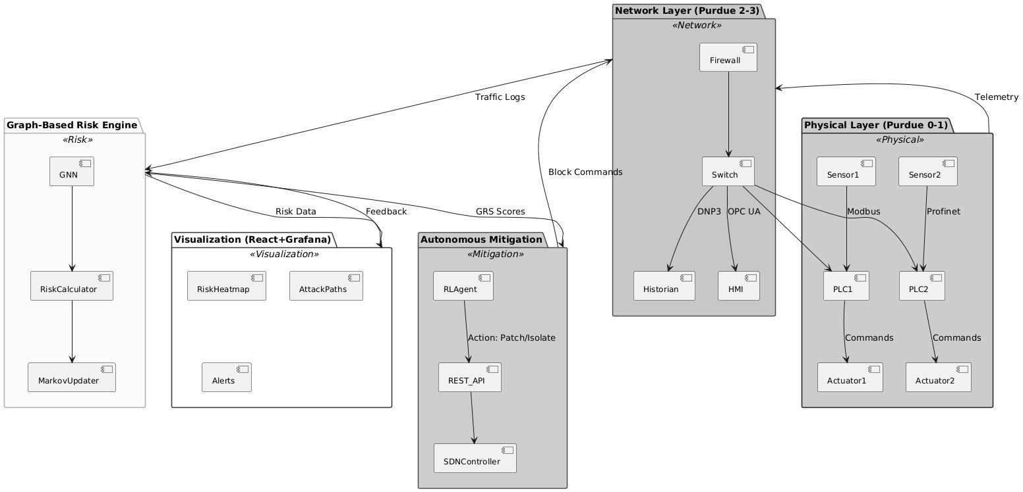
Figure 3.1: Proposed PLC-CRM Model Architecture
3.3.1 Model Description
The Dynamic Cybersecurity Risk Management Model for PLCs in Industrial Control Systems is a continuous, adaptive framework designed to address evolving cyber threats in industrial environments. Unlike traditional static risk models, this approach emphasizes real-time monitoring, threat intelligence integration, and automated response mechanisms to mitigate risks dynamically. The model operates in a cyclical process, incorporating risk identification, assessment, mitigation, and continuous improvement. It begins with real-time asset monitoring, where PLCs and connected ICS components are continuously scanned for vulnerabilities, anomalies, and potential attack vectors. Threat intelligence feeds and behavioral analytics enhance detection accuracy by identifying known and emerging threats.
Once risks are detected, an adaptive risk assessment phase evaluates their potential impact on operational integrity, safety, and availability. This assessment considers contextual factors such as system criticality, attack likelihood, and cascading effects. Based on the risk level, automated mitigation strategies are deployed, including network segmentation, access control adjustments, or patch deployment. A key feature of this model is its feedback-driven learning mechanism, where incident data and mitigation outcomes refine future risk predictions and response strategies. This ensures the model evolves alongside the threat landscape, maintaining resilience against sophisticated cyberattacks targeting PLCs in ICS environments. By integrating real-time analytics, machine learning, and automated defences, this dynamic model provides a proactive and scalable solution to cybersecurity challenges in industrial automation systems. Each layer of the model is discussed below:
1. Physical Layer (Purdue Levels 0-1) - Components and Security Risks
The Physical Layer (Purdue Levels 0-1) consists of field devices that directly interact with industrial processes, including sensors, Programmable Logic Controllers (PLCs), and actuators. These components are responsible for real-time monitoring and control but are vulnerable to cyber threats due to legacy protocols and limited security measures.
Components
- Sensors (Temperature/Pressure/Flow) Continuously collect real-time process data (e.g., tank levels, pipeline pressure, temperature readings). They transmit data using unencrypted industrial (Modbus, PROFINET) making them susceptible to interception and manipulation.
  - PLCs (Master/Slave) Execute control logic (ladder diagrams, function block diagrams) to automate industrial processes. It receives sensor inputs, process them, and send command signals to actuators (e.g., "Open Valve," "Start Motor," "Adjust Pump Speed"). It serve as the bridge between sensors and actuators, making them a prime target for cyberattacks.
  - Actuators (Valves/Motors/Pumps) Physically modify industrial processes based on PLC commands (e.g., regulating flow rates, starting/stopping motors, opening/closing valves). It rely entirely on PLC instructions, meaning any compromise in command integrity can lead to physical damage or unsafe operations.
Security Risks
- Protocol Spoofing & False Data Injection:
  - Attackers can forge sensor readings (e.g., sending fake temperature values) to trick PLCs into executing incorrect commands.
  - Impact: Disrupted processes, equipment damage, or safety hazards (e.g., overpressure in tanks).
- Firmware Exploits & Malicious Logic Injection:
  - PLC firmware can be compromised via malicious ladder logic updates (e.g., Stuxnet-style attacks).
  - Impact: Unauthorized control over actuators, leading to sabotage or industrial espionage.
- Man-in-the-Middle (MITM) Attacks:
  - Unencrypted Modbus/PROFINET traffic can be intercepted and altered in transit.
  - Impact: Commands to actuators can be modified, delayed, or replayed, causing operational failures.
- Denial-of-Service (DoS) Attacks:
  - Flooding PLCs or sensors with malicious traffic can freeze control systems, leading to process shutdowns.
- Unauthorized Physical Access:
  - Attackers with direct access to field devices can tamper with wiring or replace firmware, bypassing network security.
Mitigation Strategies
- Network Segmentation: Isolate Level 0/1 devices from higher-level networks to limit attack surfaces.
- Protocol Hardening: Implement secure versions of Modbus (Modbus Secure) or use TLS/IPSEC where possible.
- Anomaly Detection: Deploy AI/ML-based monitoring to detect abnormal sensor/PLC behavior.
- Secure Firmware Updates: Enforce digital signatures for PLC logic updates to prevent unauthorized changes.
- Physical Security Controls: Restrict access to field devices to prevent tampering.

2. Network Layer (Purdue Levels 2-3)
Components:
  - Firewall: Filters IT/OT traffic but often blind to ICS protocols.
  - Switch: Connects PLCs, HMIs, and historians.
  - OPC UA Gateway: Translates legacy protocols (Modbus → OPC UA) with encryption.
  - HMI/Historian: Supervisory control (HMI) and data logging (Historian).
Security Mechanisms:
- Micro-segmentation: Isolates PLCs from IT networks.
- Encrypted Tunnels: Modbus/TLS for legacy devices.

3. Graph-Based Risk Engine
Core Functions:
- GNN Model:
  - Input: Network topology + traffic logs.
  - Predicts Pij (attack probability between nodes).
- Risk Calculator:
  - Computes GRS(vit) using:
$GRS=∑(NRS(vj)×Pij×λ(t))GRS=∑(NRS(vj​)×Pij​×λ(t))$ (5)
- Markov Updater:
  - Adjusts edge weights dynamically based on threat feeds.
Output: Real-time risk scores per device.

4. Autonomous Mitigation Layer
Components:
- RL Agent (PPO Algorithm):
  - State: Current GRS + node vulnerabilities.
  - Actions:
    - Patch: Apply firmware updates.
    - Isolate: Disable compromised PLC ports.
    - Throttle: Limit suspicious traffic rates.
  - Reward Function:
$R=ΔGRS-0.1×PatchCost-0.3×IsolationCostR$
$=ΔGRS-0.1×PatchCost-0.3×IsolationCost$ (6)
- SDN Controller:
  - Enforces mitigation rules (e.g., block Modbus port 502).
5. Visualization & Feedback
Dashboard (React + Grafana):
- Risk Heatmap: Colors nodes by GRS (Red = Critical).
- Attack Graph: Visualizes propagation paths.
- Alerts: SMS/Email for high-risk events (e.g., GRS > 0.8).
Feedback Loop:
- Post-incident data retrain GNN/RL models.
Data Flow Sequence
- Sensor → PLC: Sends unencrypted Modbus data.
- GNN Analysis: Flags abnormal traffic (e.g., unauthorized Write, Register).
- GRS Update: Elevates risk score for affected PLC.
- RL Mitigation: Selects "Throttle Traffic" action.
- SDN Enforcement: Drops malicious packets at the switch.
- Dashboard Alert: Notifies operator with forensic details.

